Configuring/Setting up testing environment

# Purpose

The purpose of this document is to help set-up and configure a basic testing network that will allow to test out attack vectors and tools.

# Topology

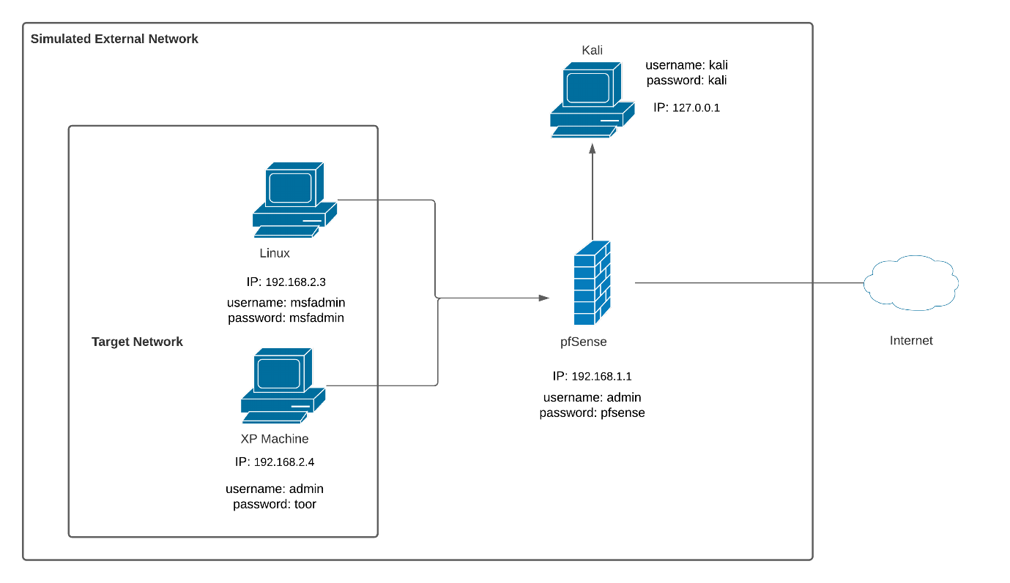

# Settings:

**Pfsense**

If running on personal computer/network, select Bridged Adapter: 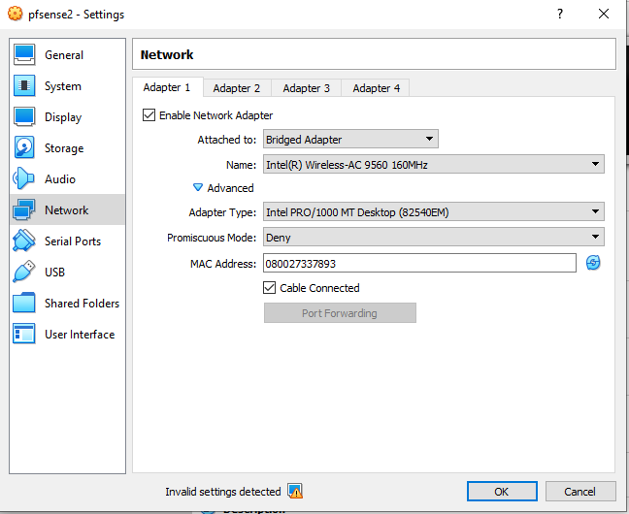

If running on Deakin network select NAT:

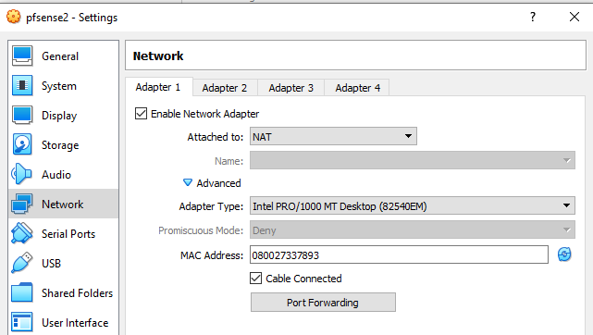

Adapter 2 settings:

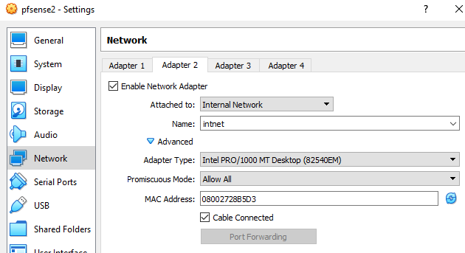

**Kali Linux:**

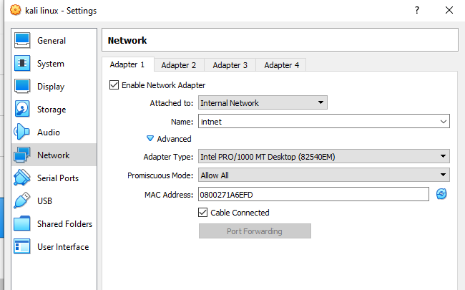

**Metasploitable**: 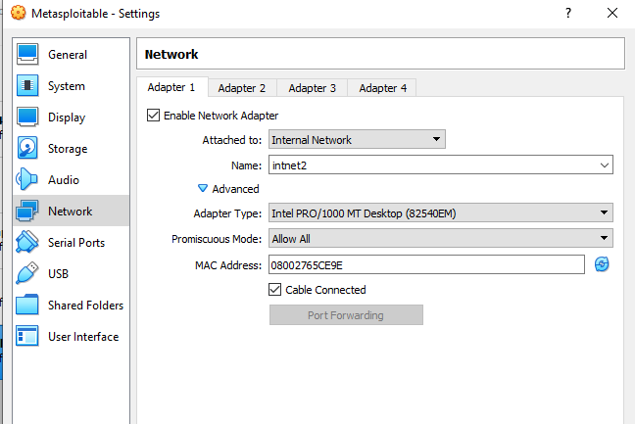

**XP machine**:

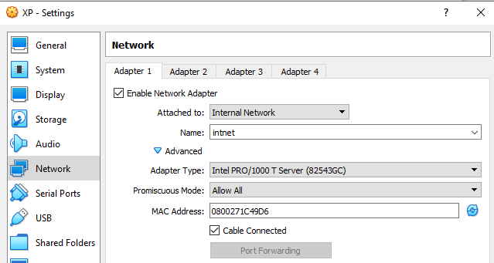

Adapter 2:

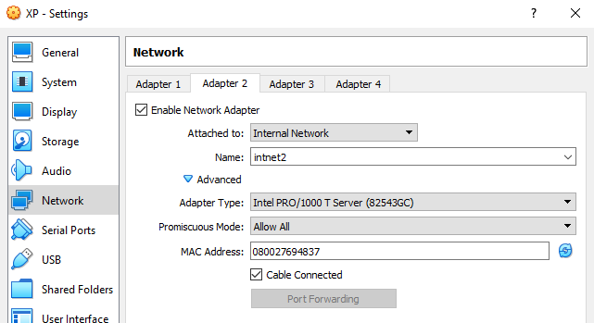

# After configuring machines:

Go back and start Pfsense. Upon starting up you should see two connections :

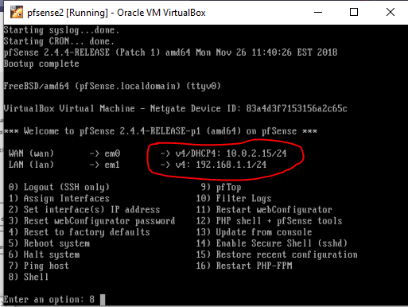

To go into shell, select 8.

Now go and start the Kali machine.

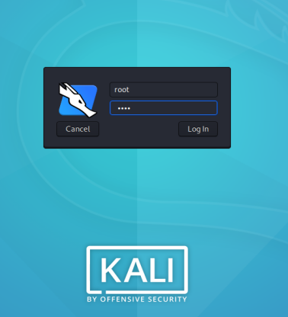

Username: kali

Password: kali

Now connect Kali to Pfsense using the Pfsense IP add: 192.168.1.1

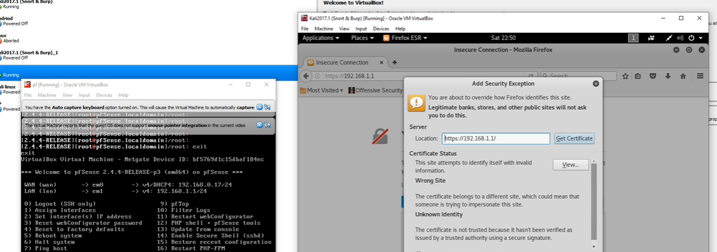

Once connect use username: admin; password: pfsense

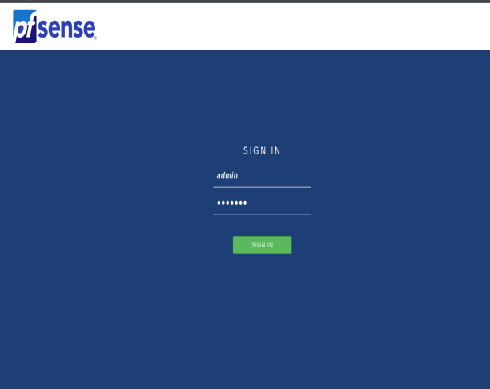

Once connect you should see this page:

